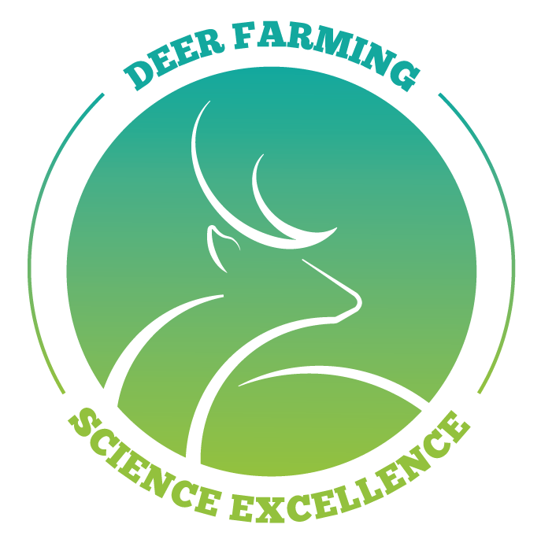
Research Proposal Template
Deer Industry New Zealand Research and Science Programme

Purpose: This document should be to communicate the nature, impact and depth of a research proposal. The template also covers pathways to adoption, or further research. These Research Proposals will be provided to the DINZ team to determine the final composition of the annual research funding. The focus of this Research Proposal should be to demonstrate knowledge generation, impact on industry and value.
Please ensure all sections of this template are completed. Any incomplete fields might result in the application not being accepted for review by the Research Advisory Panel.
Evaluation of proposals are focused on the elements of Research Need, Value to Industry, Design and Method, Research Extension, Expertise of Research Team, and Capability development.
Submissions are accepted throughout the year, however, to be included in the regular funding round, submissions must be received by 28 February.
Any enquiries about the template should be directed to the DINZ Policy and Research Manager at research@deernz.org

Date of submission:
Submitted by: (Submitters full name/s)

- Project Category – (Animal research, Farm systems, or Post farm gate)

- Research Field – e.g. genomics

- Project Title –The title of your proposal should be in plain language, be descriptive, and succinct.

- Project Overview – Should be succinct and clearly describe the proposed project to science funders and industry stakeholders.

- Link to current research – If this project is building on a current project or is part of a current pipeline of work, identify the linkage.

- Research Entity – The Organisation or entity that will be responsible for administering any awarded contract, e.g. (AgResearch, Lincoln University)

- Key contact - This is the person who will be the first contact during the project duration. Include position/qualification of the research lead/project manager.
  - – identify any other team members and their role (if applicable).

- Project parameters
  - Location - where work would be undertaken.
  - Duration of project – proposed term of the research (in months).
  - Commencement date – if application is successful.

- Funding parameters
  - Total cost of the programme - Include a supporting budget that identifies the high-level costings.
  - Funding request amount – are you seeking full funding? If not please identify other co-funders or grants applied for, and the relevant amounts.
Research Parameters
- Research Need
  - Strategic Alignment - Why is this work being undertaken, and how does this align with the Industry Strategy (see p.4)? Identify the gap that suggests this work is required (scientific enquiry, new knowledge, supporting previous research, innovation).
  - Supporting existing work - Please include supporting information if this is a piece of work that continues from prior research programmes undertaken by the industry.
  - Literature review - Has a literature review been completed prior to this proposal being submitted. (Yes/No) If yes, please attach a copy to this submission.

- Value to Industry
  - Impact - Identify the impact of the project on the industry, what types of benefits are expected and who will benefit. Give an example of how your research might be used by industry. (Note this is not science excellence)
  - Value - Indicate in dollar terms, the value proposition of the project for industry.
  - Likelihood of success - Estimate the likelihood of success (High, medium, low)

- Research Design and Methods
  - Objective/Hypothesis – Provide sufficient detail around the objectives and/or expected outcomes of the research.
  - Methodology – Provide sufficient detail to allow the committee to assess the feasibility of the programme of work.
  - O utline of Research Plan – This should include Milestones and Deliverables

- Research Uptake and Extension
  - How will the outcomes be extended to industry - Identify any proposed activities that will be undertaken to maximise the use and benefit of the research and improve uptake in the sector.
  - Who is responsible for carrying out the extension activities - If extension activities are planned, is funding included in your request sum, or is additional funding required?

- Capability development
  - Does this add deer research capability - Provide details, if any, of how the project includes students or otherwise supports the development of deer knowledge to the sector. If this is a PhD, Masters, or Honours project please note this here.

